**第 一 部 分**

**附件3（3-1） 2019年度收入支出决算总表**

|  |
| --- |
|  |
| 单位：万元    注：调整预算数指经调整后的全年预算数，包括年初预算数和预算调增调减数。  **附件3（3-2） 2019年度收入决算表** | |

单位：万元

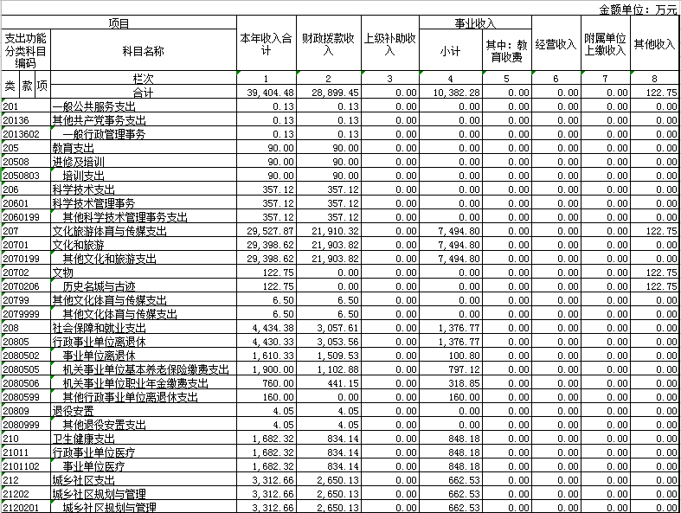

|  |  |  |  |  |  |  |  |  |  |
| --- | --- | --- | --- | --- | --- | --- | --- | --- | --- |
| **附件3（3-3） 2019年度支出决算表**  单位：万元  单位：万元  单位：万元 | | | | | | | | | |
|  |  |  |  |  |  |  |  |  |  |

**附件3（3-4） 2019年度财政拨款收入支出决算总表**

单位：万元

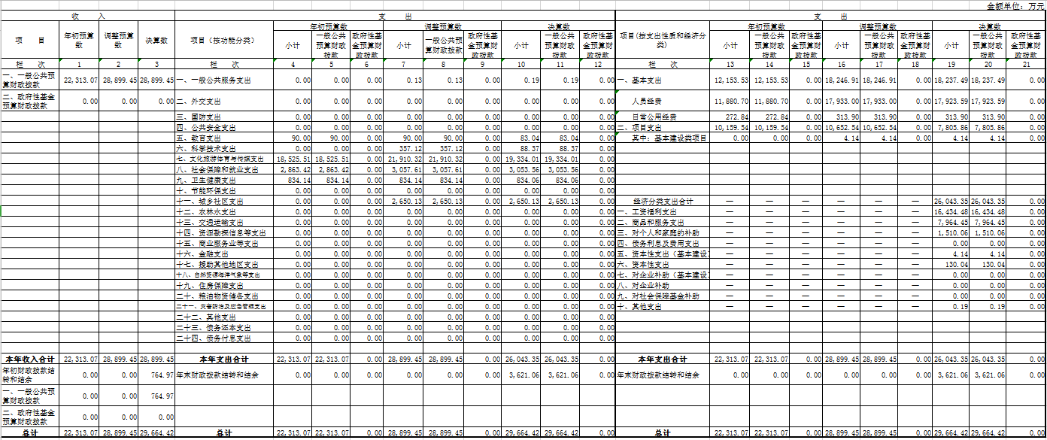

|  |  |  |  |  |  |  |  |  |  |  |  |  |
| --- | --- | --- | --- | --- | --- | --- | --- | --- | --- | --- | --- | --- |
| **附件3（3-5） 2019年度一般公共预算财政拨款支出决算表** | | | | | | | | | | | | |
|  | |  | |  | |  |  | |  | | 单位：万元 | |
| **附件3（3-6） 2019年度一般公共预算财政拨款基本支出决算表** | | | | | | | | | | | | |
|  |  | |  | |  | | |  | |  | | 单位：万元 |
|  | | | | | | | | | | | | |

|  |  |  |  |  |  |  |  |  |  |  |  |  |  |  |  |  |  |  |  |  |  |  |  |  |  |  |  |  |  |  |  |  |  |  |  |  |  |  |  |  |  |  |  |  |  |  |  |  |  |  |  |  |  |  |  |  |  |  |  |  |  |  |  |  |  |  |  |  |  |  |  |  |  |  |  |  |  |  |  |  |  |  |  |  |  |  |  |  |  |  |  |  |  |  |  |  |  |  |  |  |  |  |  |  |  |  |  |  |  |  |  |  |  |  |  |  |  |  |  |  |  |  |  |  |  |  |  |  |  |  |  |  |  |  |  |  |  |  |  |  |  |  |  |  |  |  |  |  |  |  |  |  |  |  |  |  |  |  |  |  |  |  |  |  |  |  |  |  |  |  |  |  |  |  |  |  |  |  |  |  |  |  |  |  |  |  |  |  |  |  |  |  |  |  |  |  |  |  |  |  |  |  |  |  |  |  |  |  |  |  |  |  |  |  |  |  |  |  |  |  |  |  |  |  |  |  |  |  |  |  |  |  |  |  |  |  |  |  |  |  |  |  |  |  |  |  |  |  |  |  |  |  |  |  |  |  |  |  |  |  |  |  |  |  |  |  |  |  |  |  |  |  |  |  |  |  |  |  |  |  |  |  |  |  |  |  |  |  |  |  |  |  |  |  |  |  |  |  |  |  |
| --- | --- | --- | --- | --- | --- | --- | --- | --- | --- | --- | --- | --- | --- | --- | --- | --- | --- | --- | --- | --- | --- | --- | --- | --- | --- | --- | --- | --- | --- | --- | --- | --- | --- | --- | --- | --- | --- | --- | --- | --- | --- | --- | --- | --- | --- | --- | --- | --- | --- | --- | --- | --- | --- | --- | --- | --- | --- | --- | --- | --- | --- | --- | --- | --- | --- | --- | --- | --- | --- | --- | --- | --- | --- | --- | --- | --- | --- | --- | --- | --- | --- | --- | --- | --- | --- | --- | --- | --- | --- | --- | --- | --- | --- | --- | --- | --- | --- | --- | --- | --- | --- | --- | --- | --- | --- | --- | --- | --- | --- | --- | --- | --- | --- | --- | --- | --- | --- | --- | --- | --- | --- | --- | --- | --- | --- | --- | --- | --- | --- | --- | --- | --- | --- | --- | --- | --- | --- | --- | --- | --- | --- | --- | --- | --- | --- | --- | --- | --- | --- | --- | --- | --- | --- | --- | --- | --- | --- | --- | --- | --- | --- | --- | --- | --- | --- | --- | --- | --- | --- | --- | --- | --- | --- | --- | --- | --- | --- | --- | --- | --- | --- | --- | --- | --- | --- | --- | --- | --- | --- | --- | --- | --- | --- | --- | --- | --- | --- | --- | --- | --- | --- | --- | --- | --- | --- | --- | --- | --- | --- | --- | --- | --- | --- | --- | --- | --- | --- | --- | --- | --- | --- | --- | --- | --- | --- | --- | --- | --- | --- | --- | --- | --- | --- | --- | --- | --- | --- | --- | --- | --- | --- | --- | --- | --- | --- | --- | --- | --- | --- | --- | --- | --- | --- | --- | --- | --- | --- | --- | --- | --- | --- | --- | --- | --- | --- | --- | --- | --- | --- | --- | --- | --- | --- | --- | --- | --- | --- | --- | --- | --- | --- | --- | --- | --- | --- | --- | --- | --- | --- | --- | --- | --- | --- | --- | --- | --- | --- | --- | --- | --- |
| |  |  |  |  |  |  |  |  |  |  | | --- | --- | --- | --- | --- | --- | --- | --- | --- | --- | | **附件3（3-7） 2019年度政府性基金预算财政拨款支出决算表** | | | | | | | | | | |  |  |  | |  | |  | |  | 单位：万元 | | 项 目 | | | | | | **2019年度决算数** | | | | | 支出功能分类科目编码 | | | | | 科目名称 | 合计 | 基本支出 | | 项目支出 | | 类 | 款 | | 项 | | 栏次 | 1 | 2 | | 3 | |  |  | |  | | 合计 |  |  | |  | |  |  | |  | |  |  |  | |  | |  |  | |  | |  |  |  | |  | |  |  | |  | |  |  |  | |  | |  |  | |  | |  |  |  | |  | |  |  | |  | |  |  |  | |  | |  |  | |  | |  |  |  | |  | |  |  | |  | |  |  |  | |  | |  |  | |  | |  |  |  | |  | |  |  | |  | |  |  |  | |  |  |  |  |  |  |  |  |  |  |  |  | | --- | --- | --- | --- | --- | --- | --- | --- | --- | --- | | **附件3（3-8） 2019年度政府性基金预算财政拨款基本支出决算表** | | | | | | | | | | |  |  |  | |  | |  | |  | 单位：万元 | | 项 目 | | | | | | **2019年度决算数** | | | | | 支出功能分类科目编码 | | | | | 科目名称 | 合计 | 基本支出 | | 项目支出 | | 类 | 款 | | 项 | | 栏次 | 1 | 2 | | 3 | |  |  | |  | | 合计 |  |  | |  | |  |  | |  | |  |  |  | |  | |  |  | |  | |  |  |  | |  | |  |  | |  | |  |  |  | |  | |  |  | |  | |  |  |  | |  | |  |  | |  | |  |  |  | |  | |  |  | |  | |  |  |  | |  | |  |  | |  | |  |  |  | |  | |  |  | |  | |  |  |  | |  | |  |  | |  | |  |  |  | |  |   **附件3（3-9） 2019年度“三公”经费财政拨款支出决算表** |
| |  |  |  |  |  |  |  | | --- | --- | --- | --- | --- | --- | --- | | **附件3（3-10） 2019年度政府购买服务财政拨款情况表** | | | | | | | |  |  |  |  |  |  | 单位：万元 | |